第一天： First day:  
1：你好！很高兴 认识你。我是来自Tinder 某某。

1: Hello! Nice to meet you. I'm from Tinder （name）.

2：你今天过得怎么样？

2: How is your day going?

客户：我今天很好！

Client: I'm fine today!

3: 你在Tinder上面寻找什么呢？

客户：好朋友/男女朋友

我在寻找一个男朋友或者好朋友。但是Tinder有很多粗鲁的人。我认为你是一个有礼貌的人。

3: What are you looking for on Tinder?

Client: Good friends/boyfriend/girlfriend

I'm looking for a boyfriend or a best friend. But Tinder has a lot of rude people. I think you are a polite person.

4: 你想找什么样的好朋友/男女朋友?

客户：漂亮 / 美丽/可爱...........

我喜欢有责任心，尊重女性的男人。

4: What kind of good friend/girlfriend do you want?

Client: Pretty / Beautiful / Lovely ...........

I like men who are responsible and respect women.

5：我是单身。你结婚了吗？

5： 我今年XX岁。你几岁了？

5: I'm single. Are you married?

5: I am XX years old. How old are you?

6：我是做XX行业的。你是做什么行业的？

我之前在中国。我来XX城市很XX年了。我认为这里很好

我计划以后在这里定居。

6: I'm in the XX industry. What kind of industry are you in?

I was in China before. I've been coming to XX city for very XX years. I think it's very nice here.

I plan to settle here in the future.

7：你有什么兴趣爱好呢？

客户：高尔夫 旅行 ........... 顺着客户的爱好了解：

旅行:你去过哪些有趣的国家？ 客户回答：.....................

我也很喜欢旅游。我去过英国，法国，比利时，意大利，马来西亚，，日本，韩国，菲律宾，澳大利亚，新西兰，新加坡，美国，加拿大。（马蜂窝寻找旅行的照片）与客户分享

客户回复什么就顺着聊。例如：客户回复我喜欢英国，美国。（打开百度去搜索美国，英国的著名景点）

顺着景点继续聊 (不懂就百度）

高尔夫: 你平时都在哪里打高尔夫。 顺着他说的聊。

7: What are your hobbies and interests?

Customer: Golf, travel ........... (Go along with the client's hobbies to understand).

Travel:What interesting countries have you been to? Customer answer: .....................

I also like to travel a lot. I have been to England, France, Belgium, Italy, Malaysia,, Japan, Korea, Philippines, Australia, New Zealand, Singapore, USA, Canada. (http://www.mafengwo.cn/ looking for photos of the trip) Share with the client

Talk along with whatever the customer replies. For example: the customer replied I like the United Kingdom, the United States. (Open Baidu to search for famous attractions in the United States and the United Kingdom)

Continue to talk along with the attractions (Baidu if you don't understand)

Golf: Where do you usually play golf. Talk along with what he said.

8：今天跟聊了很多。我感觉你很好。我现在要去瑜伽/睡觉/工作。我们可以交换照片吗？

交换照片后， 礼貌性赞美 。

我有事去了，下次聊

8: Talked a lot today. I feel good about you. I'm going to yoga/sleep/work now. Can we exchange photos?

After exchanging photos, polite compliments .

I have something to go to, talk to you next time

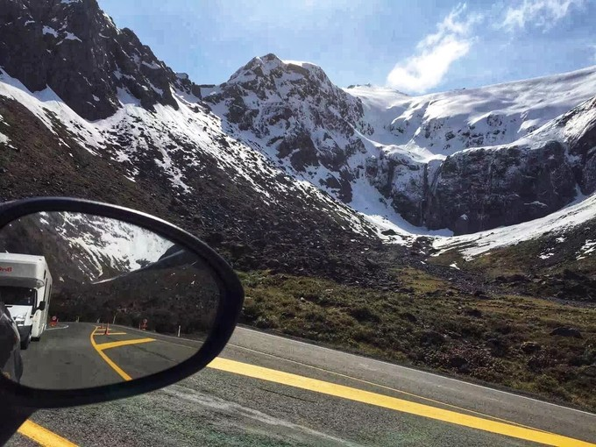  
  
  
  
  
第二天: Day 2:

工作经历： 毕业——在上海工作很多年——2019年公司安排我来到了日本——感觉日本很好，计划在这购房。

Work experience: graduated - worked in Shanghai for many years - company arranged for me to come to Japan in 2019 - felt good about Japan and planned to buy a house here.  
   
1:我来日本一年多了，日本是亚洲最发达的国家。我认为这里很好！有来自全球各地的精英。我计划在XX城市购房定居。

1:I've been in Japan for more than a year, and Japan is the most developed country in Asia. I think it's great here! There are elites from all over the world. I plan to buy a house and settle in XX city.

（问客户：你觉得你的工作怎么样？）  
2：我在上海读的大学，我本科学习的金融，硕士学习的是货币银行学。2012年我去了中国银行上海分行财务部工作。我之前在上海工作了7年。

(Ask the client: What do you think of your job?)

2: I went to university in Shanghai, I studied finance in my undergraduate degree and monetary banking in my master's degree. 2012 I went to work in the finance department of Bank of China Shanghai branch. I had worked in Shanghai for 7 years before.  
  
3：2019年公司安排我来到了中国银行东京分行担任财务总监（月薪83万日元，18薪）。

3: In 2019, my company arranged for me to come to Bank of China Tokyo branch as a finance director (monthly salary of 830,000 yen, 18 salaries).  
  
4：我来东京工作之前来过大阪旅行。日本人很有礼貌，这是吸引我的地方。因此我想了解更多的日本文化。

4: I came to Osaka for a trip before I came to work in Tokyo. Japanese people are very polite and that is what attracted me. So I wanted to learn more about Japanese culture.  
  
5:很多日本的城市，我还没去过。我想在冠状病毒之后，去更多的城市旅游。

5:There are many Japanese cities that I haven't been to yet. I want to travel to more cities after the coronavirus.  
  
  
了解客户： Know Your Customer.  
1：你觉得在东京生活压力大吗？

1: Do you find it stressful to live in Tokyo?

2：我原计划在东京买一辆TESLA，但是东京的车位太稀少了。你如何看待这个问题？

2: I was planning to buy a TESLA in Tokyo, but parking spaces in Tokyo are too scarce. How do you feel about this problem?

3：你喜欢公寓还是一户建？我更喜欢公寓，因为配套设施很齐全。

3: Do you prefer condominiums or one-family builds? I prefer condominiums because the amenities are complete.

4：你如何看待外国人在XX城市定居？

4: How do you think about foreigners settling in XX cities?  
.......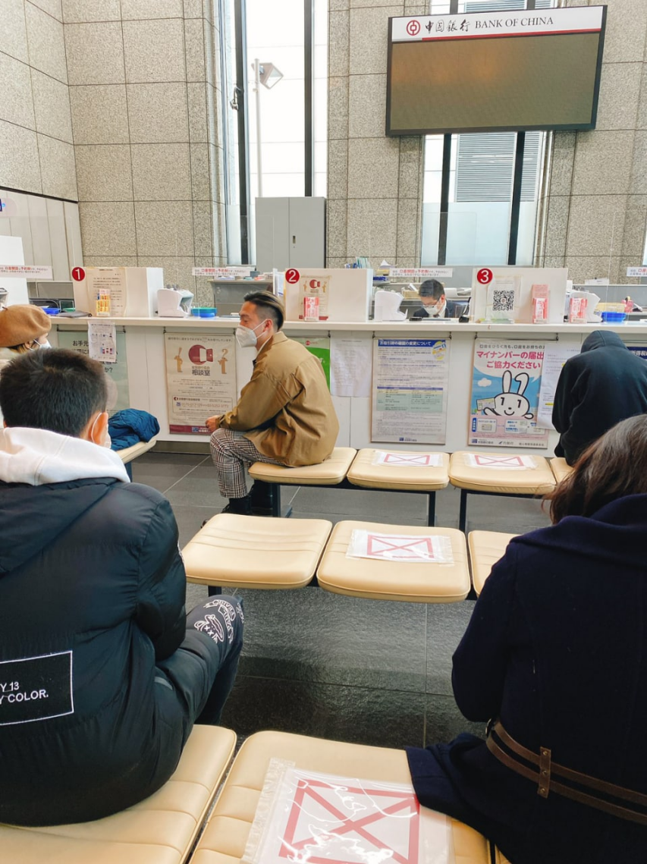...........  
  
  
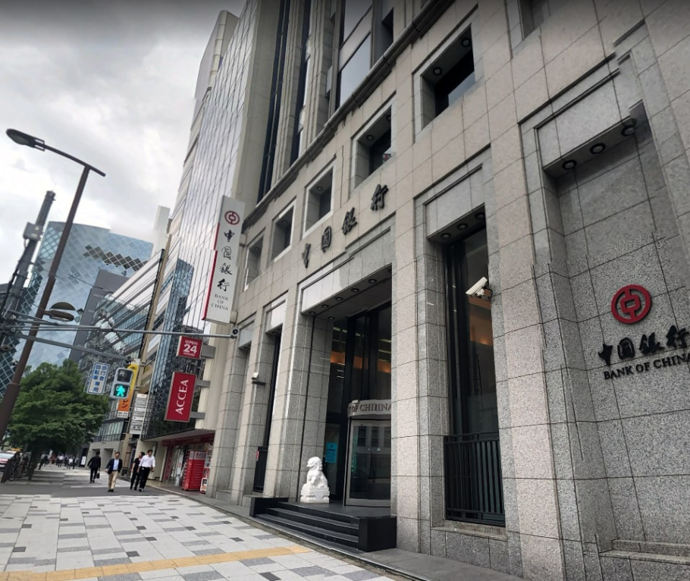  
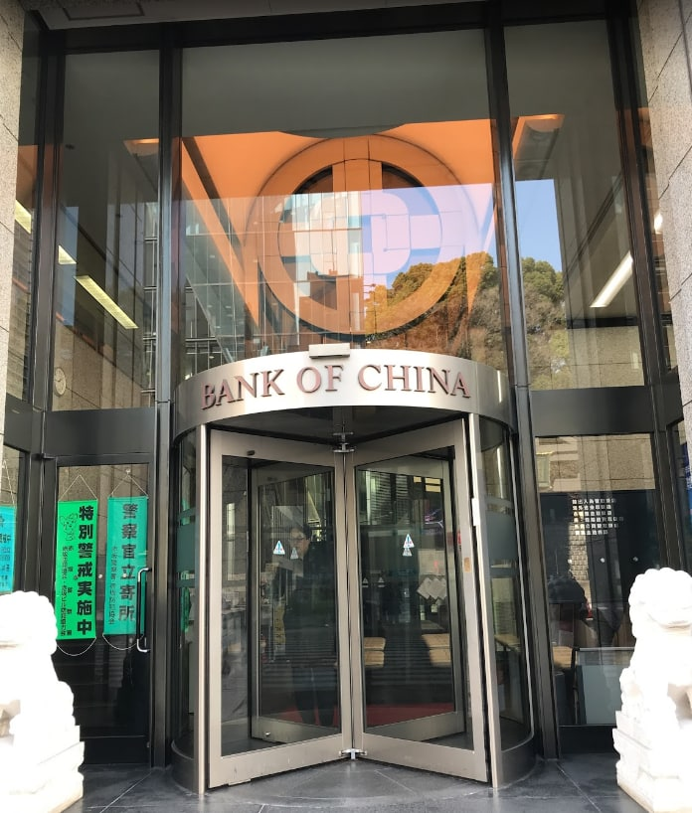  
  
  
  
  
第三天：感情经历

Day 3: Emotional experience

遇见——大学——相恋——热恋——出轨——发现——分手

met - college - fell in love - hot love - cheated - -Discovery -Breakup

我和他是在高中时期认识的。是他主动追的我。我一开始的是拒绝恋爱的，因为学生时期的我想以学业为重。他长得很帅，我当时认为他没有很认真。

I met him in high school. It was he who took the initiative to chase me. I refused to fall in love at first because I wanted to put my studies first when I was a student. He was very handsome and I didn't think he was very serious at the time.

我在一个上海读大学，大一的一天，他突然来到了我的学校，给我送来我高中三年的照片。他说喜欢我很久了，我当时很感动。那天，他在东方方明珠电视塔下面向我表白，我们在一起了。

I was in a university in Shanghai, and one day in my freshman year, he suddenly came to my school and sent me photos of my three years in high school. He said he had liked me for a long time, and I was very touched at that time. That day, he confessed his love to me under the Oriental Pearl TV Tower, and we got together.

大二的暑假。他带我去了美国加州旅行。我们从旧金山走一号公路去洛杉矶。沿途的风景震惊到了我。到了洛杉矶，我去了好莱坞。那是从小梦想要去的的地方。

Summer vacation of sophomore year. He took me on a trip to California, USA. We took Highway 1 from San Francisco to Los Angeles. The scenery along the way shocked me. When I arrived in Los Angeles, I went to Hollywood. It was the place I dreamed of going to since I was a child.

可是好景不长，大三那年。我发现他和我的好朋友在一起了。这让我很伤心。一个是我的好朋友，一个是我的男朋友。

But it didn't last long, in my junior year of college. I found out that he was with my best friend. This made me sad. One was my best friend and one was my boyfriend.

我发现他们在一起之后。我就跟他结束了两年多的感情。从那之后，我就再也没恋爱过了。

After I found out they were together. I then ended my relationship with him for over two years. I haven't been in love since then.

(你喜欢什么样的人？）

(What kind of people do you like?)

我现在想找一个有责任心的人。尊重女性的人。

I am now looking for a responsible person. Someone who respects women.  
  
了解客户：  
1：你上一段感情为什么结束呢？  
2：你对未来有什么规划吗?  
3: 你对女朋友有什么要求吗？  
4：日本人如何看待中国女性？

Understanding the client.

1: Why did your last relationship end?

2: Do you have any plans for the future?

3: Do you have any requirements for your girlfriend?

4: How do Japanese people see Chinese women?  
  
  
我现在有点事情，咱晚点聊！

I have something to do now, let's talk later!

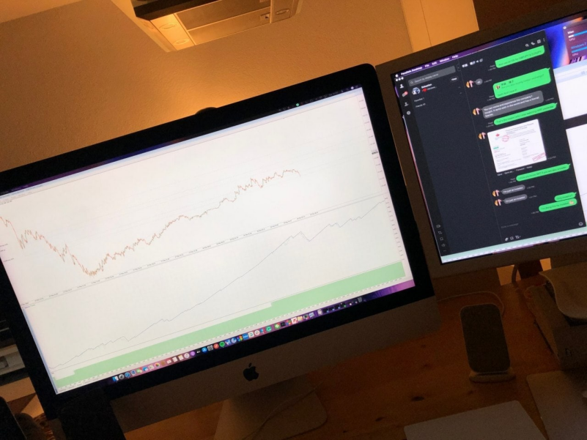

第四天：分享生活

Day 4: Sharing life  
1:我刚做完瑜伽，你在干嘛呢？

1:I just finished yoga, what are you doing?  
...............................

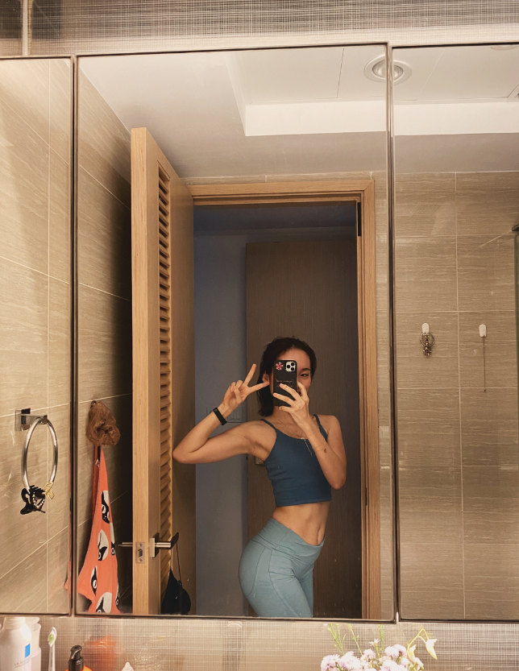  
2：讲诉自己的生活习惯，饮食习惯，与客户有更多的共鸣。

2: Speak about your own habits, eating habits, and have more empathy with your customers.

1. 3：切户方案  
   （因为我包装的人物是在银行工作的，本科硕士学习的是资本市场和货币银行学，我对数字和投资比较敏感，有一定自己的理解。这在聊工作，聊生活的时候铺垫进去了。）
2. 3: Household cutting program

(Because I packaged the character is working in the bank, undergraduate master's study of capital markets and money banking, I am more sensitive to the numbers and investment, have some understanding of their own. (This in the talk about work, talk about life when paved in.)  
  
方案1：我现在有点事情，我的老师刚才打电话给我。现在有一次重要的市场。晚点聊。  
 我很开心，我刚才完成了一笔交易。赚了XX钱。

Scenario 1: I'm kind of in the middle of something, and my teacher just called me. There is an important market right now. Talk to you later.

I'm happy, I just closed a deal. Made XX money.  
  
方案2：你最近有什么值得分享的事情吗？  
 因为美国冠状病毒的很严重，导致美元的汇率不稳定。我最近交易外汇市场赚了XXX钱。

Scenario 2: Do you have anything worth sharing lately?

The exchange rate of the US dollar is unstable because of the very serious US coronavirus. I recently made XXX money trading the foreign exchange market.  
   
赚钱之后，  
1：我计划向美国贫民地区捐款1万美金。美国是一个伟大的国家，因为这次疫情。经济倒退了很多。  
2：我会选择早点退休，去领略全球各国独有的美.  
我很希望希腊哲学，所有我有计划去希腊生活几年。  
3:环游世界..........  
（饼都是自己画出去的，只要能记得怎么说都行。在不懂的领域多百度。）

After making money

1: I plan to donate $10,000 to the poor areas of the United States. America is a great country because of this epidemic. The economy has gone backwards a lot.

2: I will choose to retire early to enjoy the unique beauty of countries around the world.

I would love the Greek philosophy and all I have plans to live in Greece for a few years.

3:Around the world ..........

(The pie is all drawn out by itself, as long as you can remember how to say anything. (More Baidu in areas you don't understand.)  
  
**什么是外汇？**

**答：**外汇是国家法定货币之间的交换。  
外汇投资是一种理财行为，它涉及到社会学，经济学，投资学，甚至还有农业知识，矿产知识，金融知识，  
商品贸易知识等等，

What is foreign exchange?

A: Foreign exchange is the exchange of legal tender between countries.

Foreign exchange investment is a kind of financial behavior, it involves sociology, economics, investment, and even agricultural knowledge, mineral knowledge, financial knowledge, and

knowledge of commodity trade, etc.  
  
**投资期货的客户可以从那些方面去切入话题？**

**答：**期货交易是一纸标准合同的交易，一般不涉及实体商品的转移，增加了交易的风险。外汇投资的灵活性更好，风险是可以通过自身去规避的。

What are some of the areas where customers who invest in futures can cut through the conversation?

A: Futures trading is a paper transaction with a standard contract, which generally does not involve the transfer of physical commodities, increasing the risk of the transaction. Foreign exchange investment is much more flexible and the risk can be hedged by itself.

1. **如何说服投资虚拟币的客户投资外汇？**

**答：**1：虚拟货币是一个匿名资产。换言之，如果你忘记密码。这个资产就不属于你了.没有保障。  
 2：相比于虚拟货币，国家之间的法定货币更具有认可性。由各国的金融机构和联合国监管。汇率起伏比较稳定。

How to convince customers who invest in virtual currencies to invest in Forex?

A: 1: Virtual currency is an anonymous asset. In other words, if you forget your password. This asset does not belong to you. There is no protection.

2: Compared to virtual currencies, legal tender between countries is more recognized. It is regulated by the financial institutions of each country and the United Nations. The exchange rate fluctuations are more stable.

**投资股票的客户从哪些话题去引导投资外汇？**

1. **答**：A股只可以做多，不可以做空。这对交易有一定的限制。美股是可以做多，也可以做空。想要交易自如对资金有一定的要求。全球的股市都有一个特点。八成的散户都是很难从中收益。  
    外汇市场比较明朗。可以选择合适的杠杆做短线（30分钟之内就可以完成一笔交易）。相比于股票，  
   对投资的金额没有很大的要求。

What topics do customers who invest in stocks go from to guide investment in foreign exchange?

1. A: A shares can only be long, not short. This has certain restrictions on trading. U.S. stocks are allowed to go long and short. Want to trade freely on the capital requirements. The global stock market has a characteristic. Eighty percent of retail investors are very difficult to gain from.

The foreign exchange market is clearer. You can choose the right leverage to do short term (you can complete a transaction within 30 minutes). Compared to stocks.

There is no great requirement for the amount of money to be invested.  
  
**股票和外汇的区别（至少列举3个不同）**

**答：**1从交易时间来看：外汇：周一到周五24个小时不间断交易，一周120个小时都可以做交易。股票：[国家法定假日](https://wenwen.sogou.com/s/?w=%E5%9B%BD%E5%AE%B6%E6%B3%95%E5%AE%9A%E5%81%87%E6%97%A5&ch=ww.xqy.chain" \t "https://wenwen.sogou.com/z/_blank)除外的周一到周五的5个工作日的每天的4-8小时。  
2从[交易方式](https://wenwen.sogou.com/s/?w=%E4%BA%A4%E6%98%93%E6%96%B9%E5%BC%8F&ch=ww.xqy.chain" \t "https://wenwen.sogou.com/z/_blank)来看：外汇：T+0的交易方式，就是说当天买多或者卖空的单子，在盈利之后，当天就可以直接平仓。并且平仓后又可以马上做其他的单子。每天的交易量是没有限制的，只要你的资金足够，每天可以无数次的买进卖出。股票：T+1的交易方式。没有外汇灵活。今天买进的只有等到明天开盘之后才能卖出。

3第五：从市场来看  
外汇：国际市场，参与的人是全球的所有投资者。非常不容易被一个单一的公司或者组织所操纵。股票：国内市场，仅仅是一个[国家内部](https://wenwen.sogou.com/s/?w=%E5%9B%BD%E5%AE%B6%E5%86%85%E9%83%A8&ch=ww.xqy.chain" \t "https://wenwen.sogou.com/z/_blank)的投资每个[公司业绩](https://wenwen.sogou.com/s/?w=%E5%85%AC%E5%8F%B8%E4%B8%9A%E7%BB%A9&ch=ww.xqy.chain" \t "https://wenwen.sogou.com/z/_blank)的发展前景而取得分红分喜的一种投资。很容易受到庄家的操作。

The difference between stocks and foreign exchange (list at least 3 differences)

A: 1 from the trading hours: foreign exchange: Monday to Friday 24 hours of non-stop trading, 120 hours a week can do transactions. Stocks: 4-8 hours a day from Monday to Friday of the 5 working days except for national holidays.

2 from the trading method: foreign exchange: T + 0 trading method, that is, the day to buy more or sell short orders, after the profit, the day you can directly close the position. And after closing the position and can immediately do other single. There is no limit to the daily trading volume, as long as you have enough money, you can buy and sell countless times a day. Stocks: T+1 trading method. Not as flexible as Forex. Buy today only until after the opening of the market tomorrow to sell.

3 Fifth: from the market

Foreign exchange: international market, the people involved are all investors around the world. Very unlikely to be manipulated by a single company or organization. Stocks: the domestic market, just a country within the development prospects of investment in each company's performance and obtain dividends to share the joy of an investment. Very susceptible to manipulation by bankers.